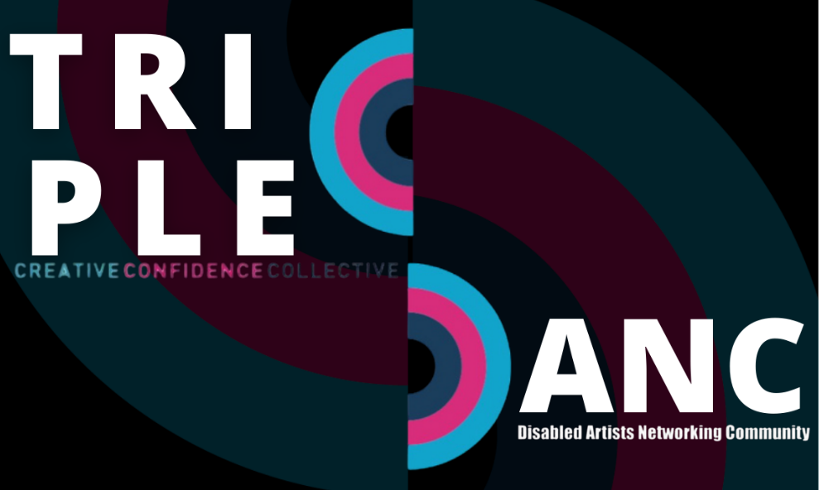

Driving Change in Scotland

Talent Directory

Last updated:

18 September 2025


Contents
Introduction 3
Access Coordinators 4
Crew 7
Directors 13
On-screen Talent 19
Post Production 28
Writers 31

End of Section

Introduction

TripleC, in collaboration with Sara Harkins, have been awarded funding by Screen Scotland to undertake a year-long programme which seeks to support deaf, disabled and/or neurodivergent (DDN) talent across Scotland.

Amongst our in-person and online events and other work, this programme is building an online talent directory to support the industry to find and hire Scotland-based DDN talent at all career levels.

This resource is free to access. It is a live document that will be added to as more DDN talent sign up.

If you would like to be included in this directory, please answer the questions on this form.

Alternatively, you can email your answers to triplecscotland@gmail.com.
End of Section

Access Coordinators / Consultants
Emilia Beatriz
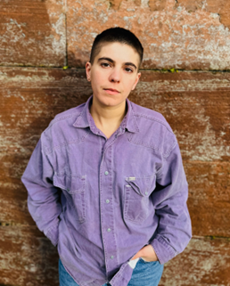
Filmmaker & Access Worker
emiliabeatrizstudio@gmail.com
Project | Instagram
List End

Jacqueline Houston
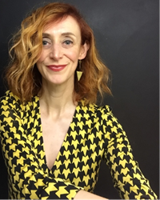
ScreenSkills-trained Access Co-ordinator/Factual TV Producer
jacquelinehouston@ntlworld.com
Empathetic and pragmatic Access Co-ordinator/Factual TV Producer (ex-BBC staff) with a love of creative problem-solving, story-telling and highlighter pens. A full BAFTA member, I’m experienced in Factual Entertainment, Arts, History, Science and Documentary, with an in-depth knowledge of production, high-end talent management and of wrangling often-complicated logistics owing to my 25 years of filming across the UK, Europe, USA, India & Africa. Pro-drama, anti-dramatics, I’m calm, collegiate and committed to facilitating access provision for all, ensuring the needs of a very diverse range of people are met, be it cast, crew or HoDs. Glasgow-based but available UK-wide; good working knowledge, and love of, Liverpool/London/Brighton.
List End

Daniel Leckerman
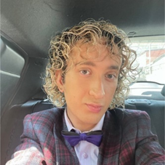
Songwriter | Access Consultant
daniel.leckerman@hotmail.co.uk
LinkedIn | Instagram
List End

Helen McEwan

ScreenSkills-trained Access Coordinator | Hair & Makeup Artist
helen_mcewan@hotmail.com
LinkedIn | IMDB
List End

Rhona McKenzie Lang
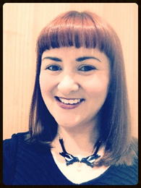
Access Coordinator | Actor | Comedian | Producer | Writer
rhonamckenzie@gmail.com
LinkedIn
List End

Michelle Rolfe
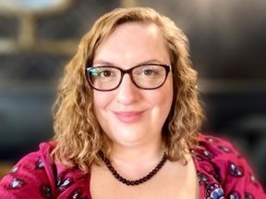
ScreenSkills-trained Access Coordinator | Producer | Access Consultant michellerolfeuk@gmail.com
Linktree
List End

Alison Smith
Access Coordinator HETV | Equalities Diversity & Inclusion Consultant for Creative industries
alisonvsmith@gmail.com
LinkedIn | Agent | Instagram | X
List End

Bea Webster-Mockett
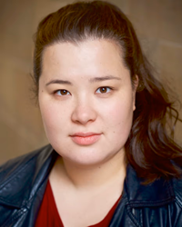
Actor | Writer | ScreenSkills-trained Access Coordinator
beanapha@gmail.com
Spotlight | Agent
End of Section

Crew
Caz Armstrong
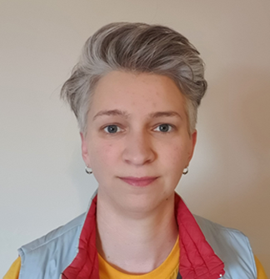
VFX Coordinator | Dept Coordinator
cazarmstrong27@gmail.com
IMDB
VFX Coordinator with a career history in organisational and coordination roles. Experience managing large amounts of complex information in both shoot and post-production. Experience using Excel, Sheets, Shotgrid, Aspera, Anchor, Syncsketch.
Previous career in investment finance, in business management and budgeting roles. I have a hidden disability which has variable effects.
List End

Viki Carter

Floor Runner | Assistant Director
Vikicarter0@gmail.com
Own website
Neurodivergent
List End

Sophie Chen
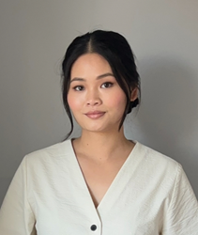
Costume | Wardrobe
sophiechen987@gmail.com
I don't have website but my CV is available.
As a BSL user, I require accessibility. I would like to include film production as costume or wardrobe.
List End

Deborah Dow
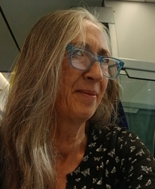
Production Runner | Production Secretary
debsdow@live.co.uk
Worked as green room host and runner for BBC Scotland Edinburgh festival; production runner on The Big Scottish Book Club series 6. BA Hons TV graduate (Napier University). Qualified First Aider and Scottish mental health first aid.
List End

Tirzah Ellen
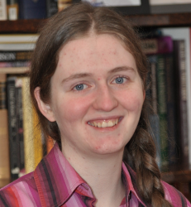
Post-Production Runner | Edit Trainee
ellentirzah@gmail.com
Own website
List End

Sara Hamilton
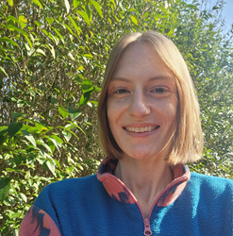
Sustainability
shamilton7419@gmail.com
List End

Samantha Jack
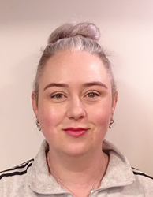
Makeup Artist | SFX Makeup Artist
samanthajack@hotmail.co.uk
IMDB
Over a decade of TV, film & commercial on-set experience.
List End

Stephanie Johnstone
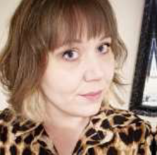
Assistant Production Accountant
stephanie_johnstone@outlook.com
IMDB
List End

Paul Daniel Lucas
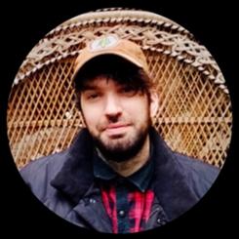
Sound Designer | Composer | Dubbing Mixer
info@audiodromedesign.com
Own website | IMDB
List End

Sam Mackie
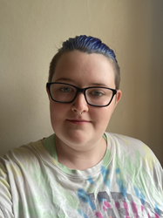
Runner | Art Department Assistant
Sammackie27@gmail.com
Own website | CV
Based in Glasgow. Graduate of the Amazon Prime Craft Academy
List End

Helen McEwan
ScreenSkills-trained Access Coordinator | Hair & Makeup Artist
helen_mcewan@hotmail.com
LinkedIn | IMDB
List End

Neale Mcintosh
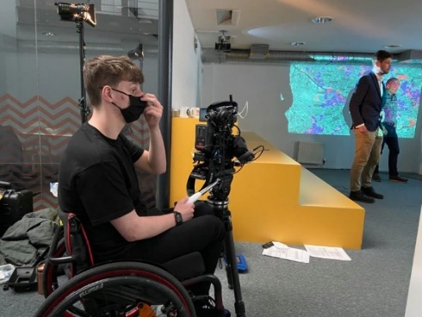
Factual Casting | Shooting | Archive researcher | Camera Trainee
Nealemc5@outlook.com
Talent Manager | LinkedIn
List End

Hazel Palmer
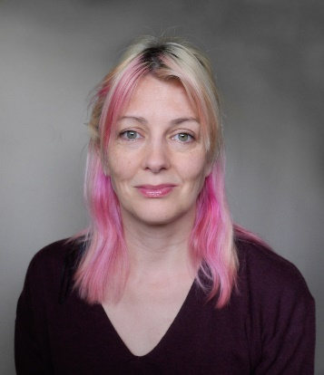
Camera Operator
hazel@hazelpalmer.com
Talent Manager | LinkedIn | Instagram
List End

Rhianonne Stone
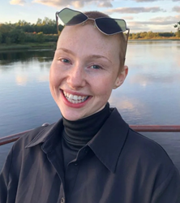
Art Department | Set Dec Department
rhianonnestone@gmail.com
Own website
List End

SJ Thomson
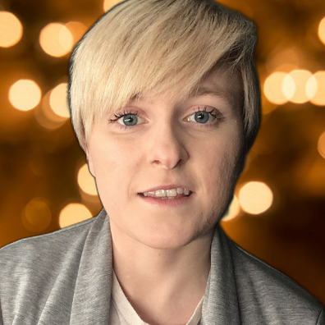
Assistant Script Editor / Researcher / Writer
sjthomson2010@gmail.com
LinkedIn
List End

David Twyman
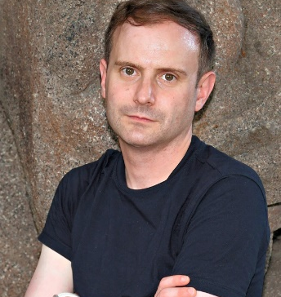
Script Editor, Television Drama
davidjtwyman@yahoo.co.uk
CV | LinkedIn
End of Section

Directors
Chris Aitken
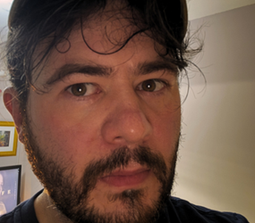
Producer | Director | Writer | Editor
chris.aitken@restlessnativeproductions.org
Own website
Neurodivergent multi-hyphenate that specialises in comedy running two film festivals.
List End

Emilia Beatriz
Filmmaker | Access Worker
emiliabeatrizstudio@gmail.com
Project | Instagram
List End

Viki Carter
Floor Runner | Assistant Director
Vikicarter0@gmail.com
Own website
Neurodivergent
List End

Leonie Rae Gasson
Director
l.r.gasson@gmail.com
Own website
List End

Jack Goessens
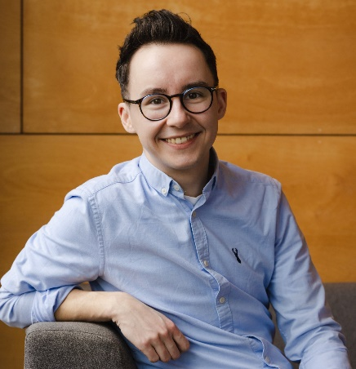
Writer | Director | Drama Editor
jackgoessens@gmail.com
Own website | Agent (Editor) | Agent (Director)
List End

Kate Hammer
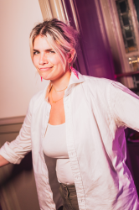
Writer | Director
katehammerwriter@gmail.com
Own website
I am a neurodivergent writer, director, and stand-up comedian who is passionate about queer stories.
List End

Amy Helena
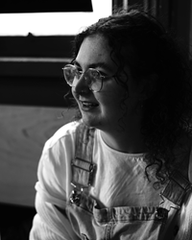
Actor | Emerging Writer / Director
info@amyhelena.scot
Spotlight | CV
List End
Craig Lowe
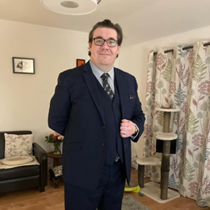
Performer | director | actor | writer | critic
Craig437lowe@gmail.com
Own website
Works in amateur theatre, keen to develop professionally.
List End

Tony McCaffery
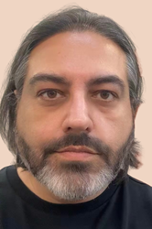
Actor | Presenter | Theatre Director | Writer
tony@diversityscotland.co.uk
LinkedIn
My pronouns are They/Them

Sarah Thomas Moffat
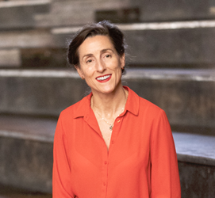
Cinematographer | Director
hello@sarahthomasmoffat.com
Own website
30 years of overall industry experience, between Canada and the UK. She has filmed on all continents and continues to expand her career. Born with a hearing loss, Sarah has used hearing aids throughout life learning ASL in Canada, and currently learning BSL in the UK.
List End

Martin Smith
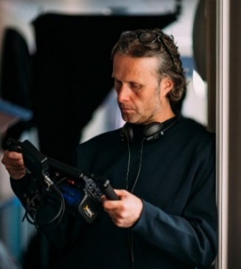
BAFTA winning TV Director | Screenwriter
martin@martinsmithonline.co.uk
Own website | Agent
List End
Abbi Stevenson
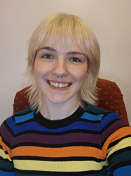
Actor | Assistant Director
abbistevenson@hotmail.com
Spotlight
I am queer, neurodivergent, disabled creative. She/They.
List End

Stephanie Symington-Kurth
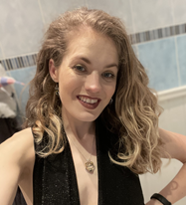
Producer | Director
Stephaniesymington@hotmail.co.uk
Own website
Open to scripted and unscripted work. Shooting and non-shooting roles. AP, PD and producer roles.
List End

Drew Taylor-Wilson
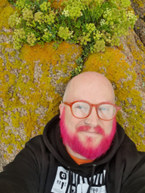
Writer | Director
Drew_taylor@hotmail.co.uk
Own website
List End

Maria Zani
Director | producer | actor | writer | development producer | disability consultant
mariazani00@gmail.com
LinkedIn | IMDB
End of Section

On-screen Talent
Marc Brew
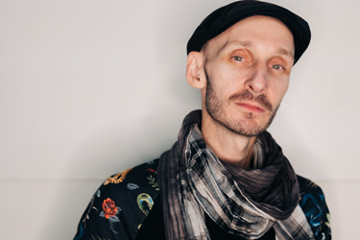
Actor | Dancer | Choreographer | Voice artist
marc@marcbrew.com
Own website | Vimeo | Youtube
Marc was presented with a Centenary Medal for Outstanding Contribution as a dancer and choreographer. His solo Remember When was nominated for an Isadora Duncan Dance Award for Best Performance (individual) and his solo work For Now, I am… was listed in the Guardians Top 10 Dance Shows for 2016. His new work an Accident / a Life in collaboration with Sidi Larbi Cherkaoui was in The Guardian Observer’s Top 5 of Dance Review 2024. He was listed No. 6 in The List Hot 100, was named a National Lottery Game Changer for Arts and was winner of the Disability Power 100 in Performing Arts, Television, Radio sponsored by Channel 4.
List End

Abigail Brydon
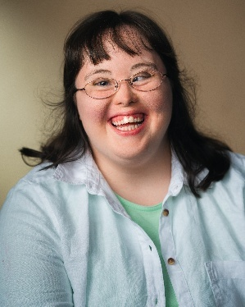
Actor | Associate Artist with Cutting Edge Theatre
cuttingedge21@btinternet.com
Spotlight
I am an actor who has toured with "Downs with Love" theatre production and recently was in a short film "Housemates" which has won a number of awards including the Berlin Short Film Awards. I have been trained as a Facilitator with Graeae and 1623 Theatre companies on their Let Me Be [Exploring Shakespeare] course and can deliver Shakespeare and drama workshops.
List End

Joseph Brown
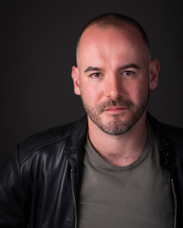
Actor
joseph.brown01@hotmail.co.uk
Spotlight
Physical Disability: Cerebral Palsy
List End

Akaisha Butler
Singer
butlerakaisha@ymail.com
Singing of the world 🌎
List End

Amy Conachan
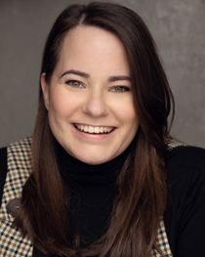
Actor
amyconachan@yahoo.com
Spotlight
List End

Chris Dalgliesh
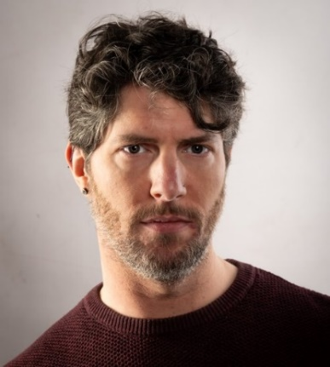
Screenwriter | Actor
c.j.dalgliesh@gmail.com
Spotlight | Spec scripts
List End

Michele Gallagher
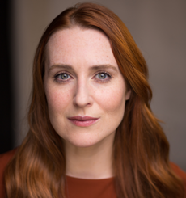
Actor | Trainee Intimacy Coordinator (NFTS)
michelefrances@googlemail.com
Spotlight
Currently training to be an Intimacy Coordinator for Film and TV at the NFTS.
List End

Edan Glennie
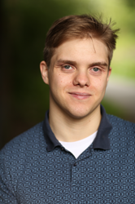
Actor
edanpglennie@hotmail.co.uk
Spotlight
I do have a language processing disorder which affects the way I understand and remember words, both written and verbal.
List End

Hannah Hebblethwaite
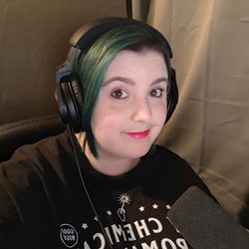
Voice Actor
hannah@hannahhebb.me
Own website
List End

Amy Helena
Actor | Emerging Writer / Director
info@amyhelena.scot
Spotlight | CV
List End

Jack Hunter
Actor | Writer
jackhunter2697@gmail.com
Spotlight
List End

Michael Keane
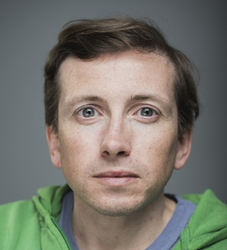
Actor | Writer
mwpkeane@gmail.com
Spotlight
List End

Lubna Kerr

Writer | producer | actor
lubnaj23@gmail.com
Own website
List End

Craig Lowe
Performer | director | actor | writer | critic
Craig437lowe@gmail.com
Own website
I’ve been working in amateur theatre for over 30 years.
List End

LH Macbeth
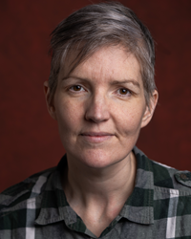
Performer
lh@macbeth-performs.com
Spotlight
List End

Tony McCaffery
Actor | Presenter | Theatre Director | Writer
tony@diversityscotland.co.uk
LinkedIn
List End

Michael McEwan
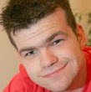
Actor | presenter | journalist | contributor
michaelmcewan43@gmail.com
Own website | Spotlight
List End

Rhona McKenzie Lang
Access Coordinator | Actor | Comedian | Producer | Writer
rhonamckenzie@gmail.com
LinkedIn
List End

Bodhrán Mullan
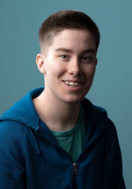
Writer | Performer
HaylzMullan@outlook.com
Spotlight
Represented by The Production Exchange Doric speaker Pronouns he/they
List End

Kirin Saeed
Actor | Writer
kirin.saeed@btinternet.com
Spotlight
Kirin is visually impaired.
List End

Neil Skene
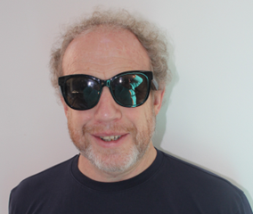
Entertainer | Stand Up Comedian | After Dinner Speaker | Actor
neil.skene@sky.com
I don't have clips, but testimonials are available on request
List End

Abbi Stevenson
Actor | Assistant Director
abbistevenson@hotmail.com
Spotlight
I am queer, neurodivergent, disabled creative. She/They.
List End

Ciaran Stewart
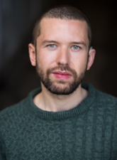
Actor
ciaranastewart@icloud.com
Spotlight
List End

Bea Webster-Mockett
Actor | Writer | ScreenSkills-trained Access Coordinator
beanapha@gmail.com
Spotlight | Agent
List End

Maria Zani
Director | producer | actor | writer | development producer | disability consultant
mariazani00@gmail.com
LinkedIn | IMDB

End of Section

Post Production
Chris Aitken
Producer | Director | Writer | Editor
chris.aitken@restlessnativeproductions.org
Own website
Neurodivergent multi-hyphenate that specialises in comedy running two film festivals.
List End

Caz Armstrong
VFX Coordinator | Dept Coordinator
cazarmstrong27@gmail.com
IMDB
VFX Coordinator with a career history in organisational and coordination roles. Experience managing large amounts of complex information in both shoot and post-production. Experience using Excel, Sheets, Shotgrid, Aspera, Anchor, Syncsketch.
Previous career in investment finance, in business management and budgeting roles. I have a hidden disability which has variable effects.
List End

Tirzah Ellen
Post-Production Runner | Edit Trainee
ellentirzah@gmail.com
Own website
List End

Skye Hassell
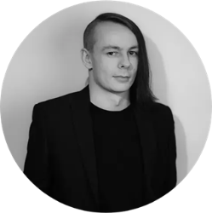
Editing
Skye.M.Hasell@gmail.com
Own website
List End

Nigel G Honey
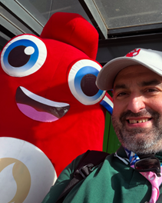
Editor | Avid & Premiere Trainer
honeynigel@gmail.com
Own website
List End

Ash Mills
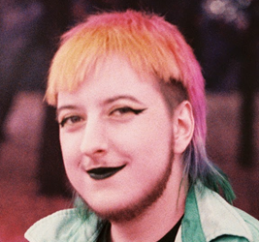
Trainee Edit Assistant
Ashsolomonmills@gmail.com
LinkedIn
Cohort of TRC rad Scotland 24/25
List End

Sam J Thomson
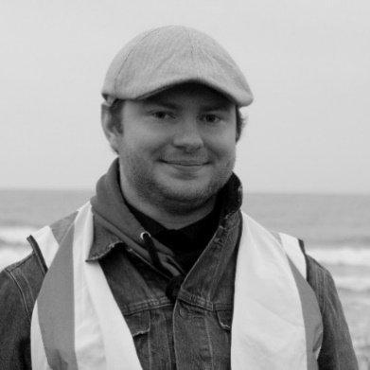
Edit Assistant | Assistant Editor | Editor
samjamesthomsonfilms@gmail.com
Own website
End of Section

Writers
Chris Aitken
Producer | Director | Writer | Editor
chris.aitken@restlessnativeproductions.org
Own website
Neurodivergent multi-hyphenate that specialises in comedy running two film festivals.
List End

Tamara Al-Bassam
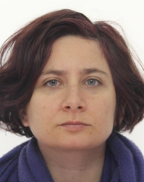
Screenwriter
Tamarareneeb@gmail.com
Own website
I have a skillset accredited MA in Playwriting from City University London and have been writing for independent film and theatre organisations since 2014. My work with Keychain Productions has won numerous awards and I debuted a monologue about my disability in 2022, which I was invited to perform again in. List End
List End

Toni 'Bones' Benedetti
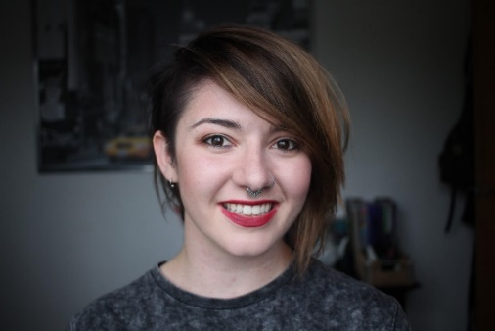
Script writer | editor
lookingfortoni@gmail.com
Own website
List End

Chris Dalgliesh
Screenwriter | Actor
c.j.dalgliesh@gmail.com
Spotlight | Spec scripts
List End

Declan Dineen
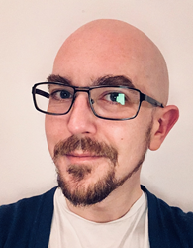
Screenwriter
declan.dineen@gmail.com
Agent
List End

Jack Goessens
Writer | Director | Drama Editor
jackgoessens@gmail.com
Own website | Agent (Editor) | Agent (Director)
List End

Rosanagh Griffiths
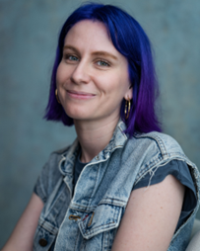
Writer | Filmmaker
rosanagh@spinsterfilms.com
Youtube
List End

Oliver Guild
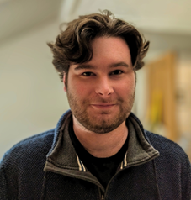
Writer of short stories and screenplays
o.timpson80@yahoo.com
Spec script
List End

Kate Hammer
Writer | Director
katehammerwriter@gmail.com
Own website
I am a neurodivergent writer, director, and stand-up comedian who is passionate about queer stories.
List End

Amy Helena
Actor | Emerging Writer / Director
info@amyhelena.scot
Spotlight | CV
List End

Jack Hunter
Actor | Writer
jackhunter2697@gmail.com
Spotlight
List End

Michael Keane
Actor | Writer
mwpkeane@gmail.com
Spotlight
List End

Michael Kelly
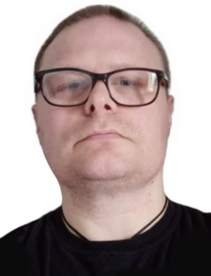
Writer | Academic | Visual Artist | Podcaster | Vocalist.
squidist@gmail.com
Podcast | Own website
List End

Lubna Kerr
Writer | producer | actor
lubnaj23@gmail.com
Own website
List End

Craig Lowe
Performer | director | actor | writer | critic
Craig437lowe@gmail.com
Own website
I’ve been working in amateur theatre for over 30 years.
List End

Ross MacKay
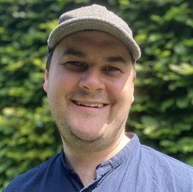
Screenwriter
rosscollinsmackay@gmail.com
Own website
List End

Tony McCaffery
Actor | Presenter | Theatre Director | Writer
tony@diversityscotland.co.uk
LinkedIn
List End

Rhona McKenzie Lang
Access Coordinator | Actor | Comedian | Producer | Writer
rhonamckenzie@gmail.com
LinkedIn
List End

David McNeish
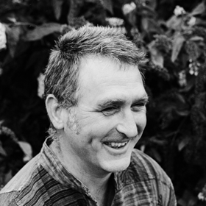
Playwright | musician | songwriter | poet | community artist
canweplay@brokendavid.com
Own website
List End

Philip Moore
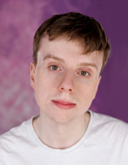
Actor | Writer
philip.moore2@hotmail.com
Spotlight
List End
Bodhrán Mullan
Writer | Performer
HaylzMullan@outlook.com
Spotlight
Represented by The Production Exchange Doric speaker Pronouns he/they
List End

Kirin Saeed
Actor | Writer
kirin.saeed@btinternet.com
Spotlight
Kirin is visually impaired.
List End

Martin Smith
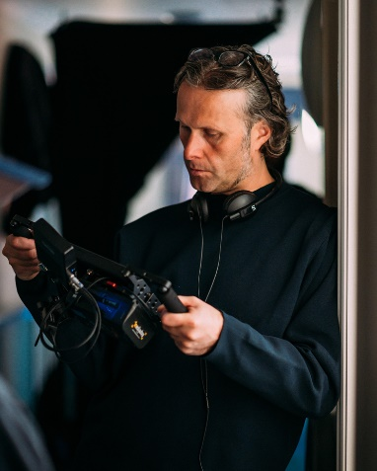
BAFTA winning TV Director | Screenwriter
martin@martinsmithonline.co.uk
Own website | Agent
List End

Dorothy Jane Stewart
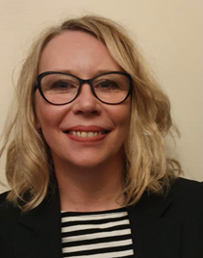
Scriptwriter
dorothyjane.stewart@sky.com
Agent
List End

Zoe Swann
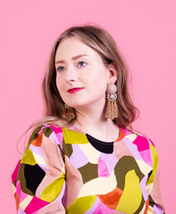
Writer
hello@zswann.com
Own website
List End

Drew Taylor-Wilson
Writer | Director
Drew_taylor@hotmail.co.uk
Own website
List End

Bea Webster-Mockett
Actor | Writer | ScreenSkills-trained Access Coordinator
beanapha@gmail.com
Spotlight | Agent
List End

Maria Zani
Director | producer | actor | writer | development producer | disability consultant
mariazani00@gmail.com
LinkedIn | IMDB
End of Section

