**Logos with circles and text.
Logo 1 says TripleC - Creative Confidence Collective.
Logo 2 says DANC - Disabled Artists Networking Community**

Driving Change in Scotland

Talent Directory

Last updated:

15 January 2025



Contents

Introduction 3

Access Coordinators 4

Crew 6

Directors 12

On-screen Talent 17

Writers 24

End of Section

# Introduction

TripleC, in collaboration with Sara Harkins, have been awarded funding by Screen Scotland to undertake a year-long programme which seeks to support deaf, disabled and/or neurodivergent (DDN) talent across Scotland.

Amongst our in-person and online events and other work, this programme is building an online talent directory to support the industry to find and hire Scotland-based DDN talent at all career levels.

This resource is free to access. It is a live document that will be added to as more DDN talent sign up.

If you would like to be included in this directory, please answer the questions on this [form](https://www.surveymonkey.com/r/TalentSignUp).

Alternatively, you can email your answers to [triplecscotland@gmail.com](mailto:triplecscotland@gmail.com).

End of Section

# Access Coordinators

**Emilia Beatriz**

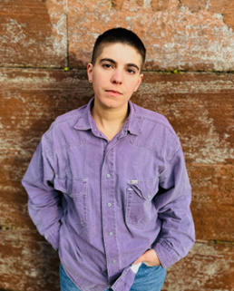

Filmmaker & Access Worker

emilixbeatrizstudio@gmail.com

[Project](https://filmfreeway.com/projects/2969391) | [Instagram](https://www.instagram.com/collectivetext)

List End

**Daniel Leckerman**

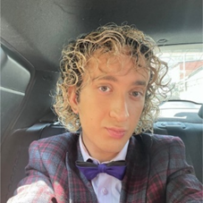

Songwriter | Access Coordinator

daniel.leckerman@hotmail.co.uk

[LinkedIn](https://www.linkedin.com/in/daniel-leckerman-327009273)

List End

**Helen McEwan**



ScreenSkills-trained Access Coordinator | Hair & Makeup Artist

helen_mcewan@hotmail.com

[LinkedIn](https://www.linkedin.com/in/helen-mcewan-0453b363/?originalSubdomain=uk) | [IMDB](https://www.imdb.com/name/nm14240867/)

List End

**Rhona McKenzie Lang**



Access Coordinator | Actor | Comedian | Producer | Writer

rhonamckenzie@gmail.com

[LinkedIn](https://www.linkedin.com/in/rhonaimrie?utm_source=share&utm_campaign=share_via&utm_content=profile&utm_medium=ios_app)

List End

**Michelle Rolfe**



ScreenSkills-trained Access Coordinator | Producer | Access Consultant michellerolfeuk@gmail.com

[Linktree](https://linktr.ee/michellerolfe)

List End

**Alison Smith**

Access Coordinator HETV | Equalities Diversity & Inclusion Consultant for Creative industries

alisonvsmith@gmail.com

[LinkedIn](https://www.casarotto.co.uk/clients/alison-smith) | [Agent](https://uk.linkedin.com/in/peskypeople) | [Instagram](https://www.instagram.com/pesky) | [X](https://x.com/peskypeople)

End of Section

# Crew

**Chris Aitken**

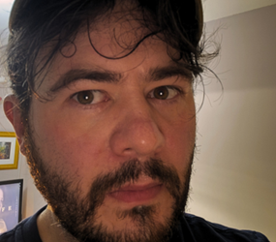

Producer | Director | Writer | Editor

chris.aitken@restlessnativeproductions.org

[Own website](https://www.restlessnativeproductions.org/)

Neurodivergent multi-hyphenate that specialises in comedy running two film festivals.

List End

**Caz Armstrong**

A headshot of white woman with short greying hair pushed back. Against a plain background


VFX Coordinator | Dept Coordinator

cazarmstrong27@gmail.com

[IMDB](https://www.imdb.com/name/nm13166308/)

VFX Coordinator with a career history in organisational and coordination roles. Experience managing large amounts of complex information in both shoot and post-production. Experience using Excel, Sheets, Shotgrid, Aspera, Anchor, Syncsketch.

Previous career in investment finance, in business management and budgeting roles. I have a hidden disability which has variable effects.

List End

**Deborah Dow**

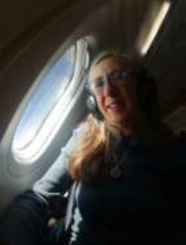

Production Runner | Production Secretary

debsdow@live.co.uk

Worked as green room host and runner for BBC Scotland Edinburgh festival.

TV credit obtained for working as Production runner - The Big Scottish Book Club series 6. BA Hons TV graduate (Napier University). Qualified First Aider and Scottish mental health first aid.

List End

**Tirzah Ellen**

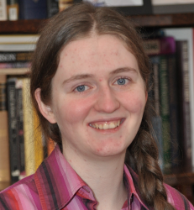

Post-Production Runner | Edit Trainee

ellentirzah@gmail.com

[Own website](https://tirzahellen.wixsite.com/portfolio)

List End

**Nigel G Honey**

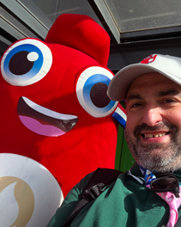

Editor | Avid & Premiere Trainer

honeynigel@gmail.com

[Own website](https://abilityacademy.co.uk/)

I have 27 years’ experience as an editor in TV and Film and live with bi polar, and set up Ability Academy - the first UK accessible, affordable and inclusive film editing academy teaching to BBC, ITV scripted Emmerdale and Coronation St.

List End

**Stephanie Johnstone**



Assistant Production Accountant

stephanie_johnstone@outlook.com

[IMDB](https://www.imdb.com/name/nm14131648/)

List End

**Paul Daniel Lucas**



Sound Designer | Composer | Dubbing Mixer

info@audiodromedesign.com

[Own website](http://www.audiodromedesign.com) | [IMDB](https://m.imdb.com/name/nm3254008/?ref_=fn_al_nm_1)

List End

**Helen McEwan**



ScreenSkills-trained Access Coordinator | Hair & Makeup Artist

helen_mcewan@hotmail.com

[LinkedIn](https://www.linkedin.com/in/helen-mcewan-0453b363/?originalSubdomain=uk) | [IMDB](https://www.imdb.com/name/nm14240867/)

List End

**Neale Mcintosh**

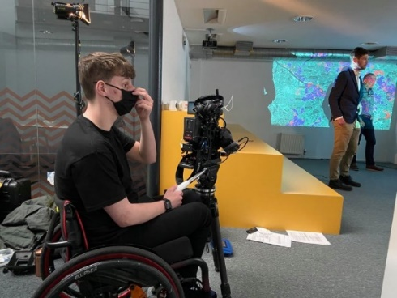

Factual Casting | Shooting | Archive researcher | Camera Trainee

Nealemc5@outlook.com

[Talent Manager](https://www.thetalentmanager.com/talent/116037/neale-mcintosh) | [LinkedIn](https://www.linkedin.com/in/neale-mcintosh-b1a09020a/?originalSubdomain=uk)

List End

**Ash Mills**

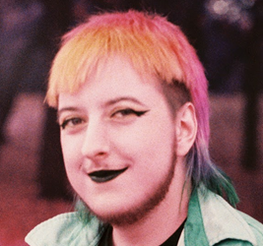

Trainee Edit Assistant

Ashsolomonmills@gmail.com

[LinkedIn](https://www.linkedin.com/in/ash-mills-77744820a/)

Cohort of TRC rad Scotland 24/25

List End

**Hazel Palmer**

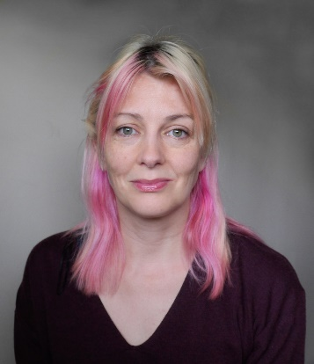

Camera Operator

hazel@hazelpalmer.com

[Talent Manager](https://www.thetalentmanager.com/talent/24036/hazel-palmer) | [LinkedIn](https://www.linkedin.com/in/hazel-palmer-63120024/) | [Instagram](https://www.instagram.com/hazelpcam/)

List End

**Rhianonne Stone**

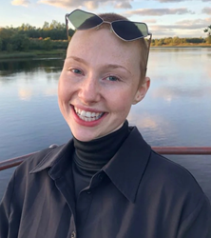

Art Department | Set Dec Department

rhianonnestone@gmail.com

[Own website](https://rhianonnestone.com/)

List End

**Sam J Thomson**

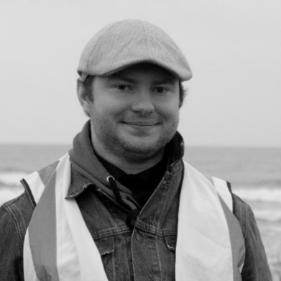

Edit Assistant | Assistant Editor | Editor

samjamesthomsonfilms@gmail.com

[Own website](https://samjthomsoneditor.wixsite.com/editor/portfolio)

List End

**SJ Thomson**

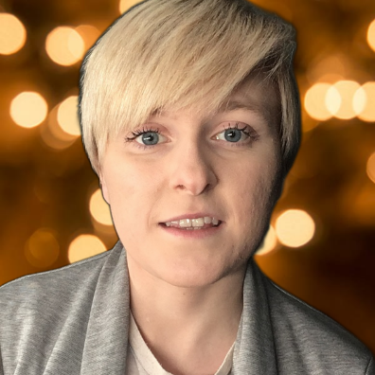

Storyliner | Researcher | Background Checker (across scripted and unscripted TV)

sjthomson2010@gmail.com

[Twitter](https://twitter.com/sahja) | [LinkedIn](https://www.linkedin.com/in/sjthomson2010/)

List End

**David Twyman**

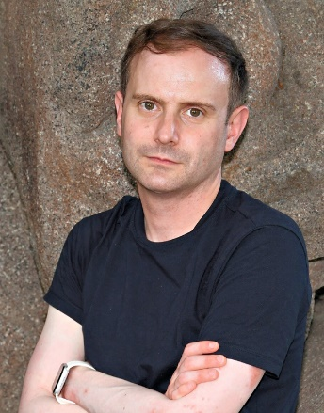

Script Editor, Television Drama

davidjtwyman@yahoo.co.uk

[LinkedIn](http://www.linkedin.com/in/david-twyman-90559320)

# Directors

**Chris Aitken**



Producer | Director | Writer | Editor

chris.aitken@restlessnativeproductions.org

[Own website](https://www.restlessnativeproductions.org/)

Neurodivergent multi-hyphenate that specialises in comedy running two film festivals.

List End

**Emilia Beatriz**



Filmmaker | Access Worker

emilixbeatrizstudio@gmail.com

[Project](https://filmfreeway.com/projects/2969391) | [Instagram](https://www.instagram.com/collectivetext)

List End

**Leonie Rae Gasson**

Director

l.r.gasson@gmail.com

[Own website](https://www.leonieraegasson.com/)

List End

**Jack Goessens**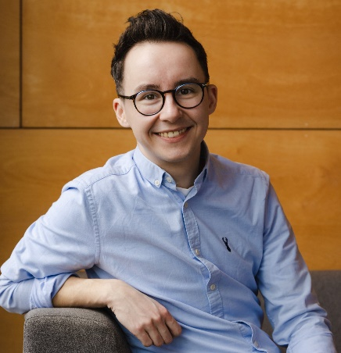

Writer | Director | Drama Editor  
jackgoessens@gmail.com  
[Own website](https://www.jackgoessens.com/) | [Agent (Editor)](https://www.berlinassociates.com/client-list/jack-goessens) | [Agent (Director)](https://www.berlinassociates.com/client-list/jack-goessens-2)

List End

**Kate Hammer**

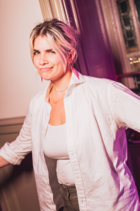

Writer | Director

katehammerwriter@gmail.com

[Own website](https://www.katethehammer.com/)

I am a neurodivergent writer, director, and stand-up comedian who is passionate about queer stories.

List End

**Craig Lowe**

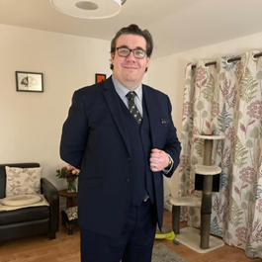

Performer | director | actor | writer | critic

Craig437lowe@gmail.com

[Own website](https://craigscozycafe.wordpress.com)

I’ve been working in amateur theatre for over 30 years, and would be keen to develop professionally. I have ME and use a walking stick to help me get about.

List End

**Tony McCaffery**

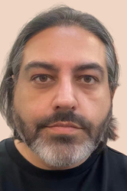

Actor | Presenter | Theatre Director | Writer

tony@diversityscotland.co.uk

[LinkedIn](https://uk.linkedin.com/in/tonymccaffery)

My pronouns are They/Them

**Martin Smith**

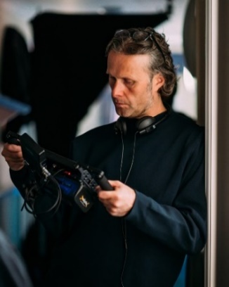

BAFTA winning TV Director | Screenwriter

martin@martinsmithonline.co.uk

[Own website](http://www.martinsmithonline.co.uk) | [Agent](https://www.unitedagents.co.uk/martin-smith)

List End

**Stephanie Symington-Kurth**

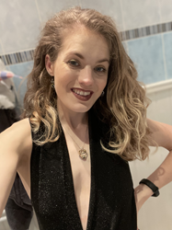

Producer | Director

Stephaniesymington@hotmail.co.uk

[Own website](https://stephaniesymington.wordpress.com/)

Open to scripted and unscripted work. Shooting and non-shooting roles. AP, PD and producer roles.

List End

**Drew Taylor-Wilson**

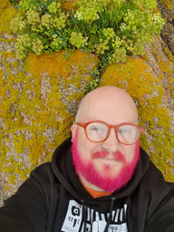

Writer | Director

Drew_taylor@hotmail.co.uk

[Own website](https://www.drewmakestheatre.com/)

List End

**Maria Zani**

**A woman with long black hair**

Director | producer | actor | writer | development producer | disability consultant

mariazani00@gmail.com

[LinkedIn](https://www.linkedin.com/in/mariazani) | [IMDB](https://www.imdb.com/name/nm6256329/)

# On-screen Talent

**Marc Brew**

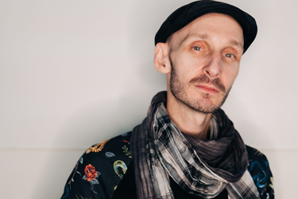

Actor | Dancer | Choreographer | Voice artist

marc@marcbrew.com

[Own website](https://www.marcbrew.com) | [Vimeo](https://vimeo.com/user6316423) | [Youtube](https://www.youtube.com/user/MarcBrewCompany)

Marc was presented with a Centenary Medal for Outstanding Contribution as a dancer and choreographer. His solo Remember When was nominated for an Isadora Duncan Dance Award for Best Performance (individual) and his solo work For Now, I am… was listed in the Guardians Top 10 Dance Shows for 2016. His new work an Accident / a Life in collaboration with Sidi Larbi Cherkaoui was in The Guardian Observer’s Top 5 of Dance Review 2024. He was listed No. 6 in The List Hot 100, was named a National Lottery Game Changer for Arts and was winner of the Disability Power 100 in Performing Arts, Television, Radio sponsored by Channel 4.

List End

**Abigail Brydon**



Actor | Associate Artist with Cutting Edge Theatre

cuttingedge21@btinternet.com

[Website](https://cuttingedgetheatre.co.uk/production/downs-with-love/)

I have been trained as a Facilitator with Graeae and 1623 Theatre companies on their Let Me Be [Exploring Shakespeare] course and can deliver Shakespeare and drama workshops.

List End

**Joseph Brown**

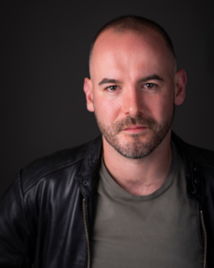

Actor

joseph.brown01@hotmail.co.uk

[Spotlight](https://app.spotlight.com/6612-8949-1707)

Physical Disability: Cerebral Palsy

List End

**Akaisha Butler**

Singer

butlerakaisha@ymail.com

Singing of the world 🌎

List End

**Amy Conachan**

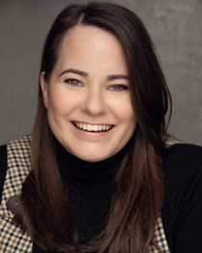

Actor

amyconachan@yahoo.com

[Spotlight](https://app.spotlight.com/4931-0197-3981)

List End

**Chris Dalgliesh**

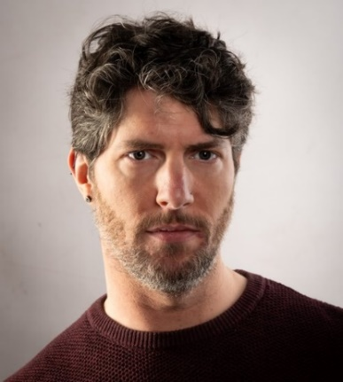

Screenwriter | Actor

c.j.dalgliesh@gmail.com

[Spec scripts](https://drive.google.com/drive/folders/1Mz2OeKB3Ui2r-LkGrlHD0dcF0cCe1eNP?usp=sharing)

List End

**Michele Gallagher**

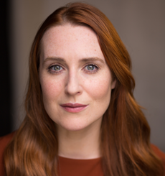

Actor | Trainee Intimacy Coordinator (NFTS)

michelefrances@googlemail.com

[Spotlight](https://app.spotlight.com/7898-7869-0652)

I have ADHD. I've been a professional actor for 24 years and I'm currently training to be an Intimacy Coordinator for Film and TV at the NFTS in Leeds.

List End

**Jack Hunter**

A man wearing a black shirt, with brown hair & facial hair smiles at the camera. The background is a mustard yellow.

Actor | Writer

jackhunter2697@gmail.com

[Spotlight](https://app.spotlight.com/9738-1277-7822)

List End

**Michael Keane**

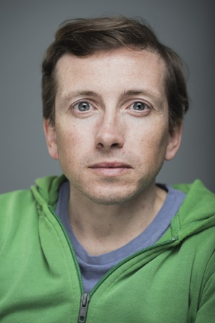

Actor | Writer

mwpkeane@gmail.com

[Spotlight](https://app.spotlight.com/9739-3493-6781)

List End

**Lubna Kerr**



Writer | producer | actor

lubnaj23@gmail.com

[Own website](http://www.lubnakerr.co.uk/)

List End

**Craig Lowe**



Performer | director | actor | writer | critic

Craig437lowe@gmail.com

[Own website](https://craigscozycafe.wordpress.com)

I’ve been working in amateur theatre for over 30 years.

List End

**Tony McCaffery**



Actor | Presenter | Theatre Director | Writer

tony@diversityscotland.co.uk

[LinkedIn](https://uk.linkedin.com/in/tonymccaffery)

My pronouns are They/Them

List End

**Michael McEwan**

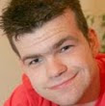

Actor | presenter | journalist | contributor

michaelmcewan43@gmail.com

[Own website](http://www.michaelmcewanmedia.com) | [Spotlight](https://app.spotlight.com/7818-8944-3924)

List End

**Rhona McKenzie Lang**



Access Coordinator | Actor | Comedian | Producer | Writer

rhonamckenzie@gmail.com

[LinkedIn](https://www.linkedin.com/in/rhonaimrie?utm_source=share&utm_campaign=share_via&utm_content=profile&utm_medium=ios_app)

List End

**Bodhrán Mullan**

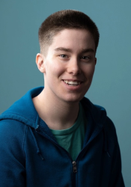

Writer | Performer

HaylzMullan@outlook.com

[Spotlight](https://app.spotlight.com/2612-4508-9792)

Represented by The Production Exchange Doric speaker Pronouns he/they

List End

**Kirin Saeed**

Kirin, a 4 foot 10 Asian woman with purple hair and grey roots is smiling warmly in front of a white background and wearing a black top.

Actor | Writer

kirin.saeed@btinternet.com

[Spotlight](https://app.spotlight.com/1890-1202-3646)

Kirin is visually impaired.

List End

**Neil Skene**

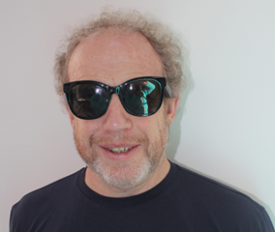

Entertainer | Stand Up Comedian | After Dinner Speaker | Actor

neil.skene@sky.com

I don't have clips, but testimonials are available on request

List End

**Ciaran Stewart**

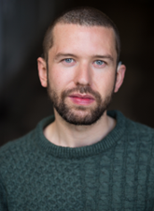

Actor

ciaranastewart@icloud.com

[Spotlight](https://app.spotlight.com/1890-1273-3047)

List End

**Maria Zani**

**A woman with long black hair**

Director | producer | actor | writer | development producer | disability consultant

mariazani00@gmail.com

[LinkedIn](https://www.linkedin.com/in/mariazani) | [IMDB](https://www.imdb.com/name/nm6256329/)

End of Section

# Writers

**Chris Aitken**



Producer | Director | Writer | Editor

chris.aitken@restlessnativeproductions.org

[Own website](https://www.restlessnativeproductions.org/)

Neurodivergent multi-hyphenate that specialises in comedy running two film festivals.

List End

**Tamara Al-Bassam**



Screenwriter

Tamarareneeb@gmail.com

[Own website](https://tralbassam.wixsite.com/tamararenee)

I have a skillset accredited MA in Playwriting from City University London and have been writing for independent film and theatre organisations since 2014. My work with Keychain Productions has won numerous awards and I debuted a monologue about my disability in 2022, which I was invited to perform again in. List End

List End

**Toni 'Bones' Benedetti**

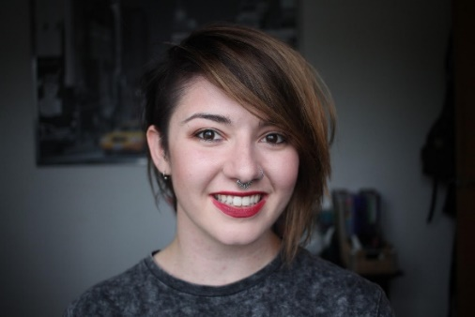

Script writer | editor

lookingfortoni@gmail.com

[Own website](https://www.lookingfortoni.com)

List End

**Chris Dalgliesh**



Screenwriter | Actor

c.j.dalgliesh@gmail.com

[Spec scripts](https://drive.google.com/drive/folders/1Mz2OeKB3Ui2r-LkGrlHD0dcF0cCe1eNP?usp=sharing)

List End

**Jack Goessens**

Writer | Director | Drama Editor  
jackgoessens@gmail.com  
[Own website](https://www.jackgoessens.com/) | [Agent (Editor)](https://www.berlinassociates.com/client-list/jack-goessens) | [Agent (Director)](https://www.berlinassociates.com/client-list/jack-goessens-2)

List End

**Rosanagh Griffiths**

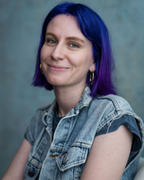

Writer | Filmmaker

rosanagh@spinsterfilms.com

[Youtube](https://youtu.be/6aJJShczljI?si=MSMrs4ejDr77-dkT)

List End

**Oliver Guild**

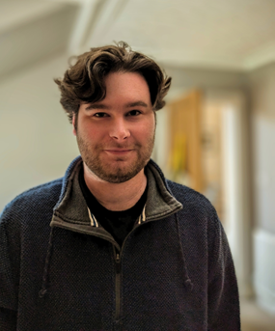

Writer of short stories and screenplays

o.timpson80@yahoo.com

[Spec script](https://drive.google.com/file/d/1H7vQ0Hgb2SCCNV9mABDmn0PE-4K-tQCJ/view?usp=sharing)

List End

**Kate Hammer**



Writer | Director

katehammerwriter@gmail.com

[Own website](https://www.katethehammer.com/)

I am a neurodivergent writer, director, and stand-up comedian who is passionate about queer stories.

List End

**Jack Hunter**

A man wearing a black shirt, with brown hair & facial hair smiles at the camera. The background is a mustard yellow.

Actor | Writer

jackhunter2697@gmail.com

[Spotlight](https://app.spotlight.com/9738-1277-7822)

List End

**Michael Keane**



Actor | Writer

mwpkeane@gmail.com

[Spotlight](https://app.spotlight.com/9739-3493-6781)

List End

**Michael Kelly**

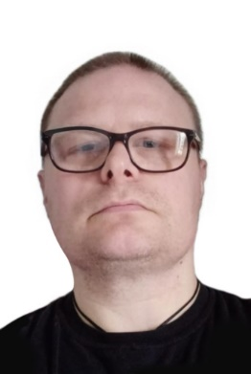

Writer | Academic | Visual Artist | Podcaster | Vocalist.

squidist@gmail.com

[Podcast](https://podcasts.apple.com/gb/podcast/yodcast-journals-of-timothy-yod-man-from-the-future/id1519514058) | [Own website](https://michaelandrewkelly.weebly.com/)

List End

**Lubna Kerr**



Writer | producer | actor

lubnaj23@gmail.com

[Own website](http://www.lubnakerr.co.uk/)

List End

**Craig Lowe**



Performer | director | actor | writer | critic

Craig437lowe@gmail.com

[Own website](https://craigscozycafe.wordpress.com)

I’ve been working in amateur theatre for over 30 years.

List End

**Ross MacKay**

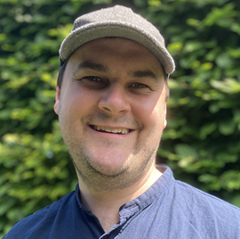

Screenwriter

rosscollinsmackay@gmail.com

[Own website](https://rossmackaystories.com/)

List End

**Tony McCaffery**



Actor | Presenter | Theatre Director | Writer

tony@diversityscotland.co.uk

[LinkedIn](https://uk.linkedin.com/in/tonymccaffery)

List End

**Rhona McKenzie Lang**



Access Coordinator | Actor | Comedian | Producer | Writer

rhonamckenzie@gmail.com

[LinkedIn](https://www.linkedin.com/in/rhonaimrie?utm_source=share&utm_campaign=share_via&utm_content=profile&utm_medium=ios_app)

List End

**David McNeish**

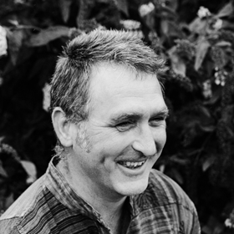

Playwright | musician | songwriter | poet | community artist

canweplay@brokendavid.com

[Own website](http://www.brokendavid.com)

List End

**Philip Moore**

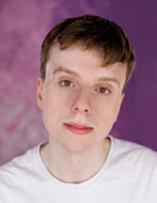

Actor | Writer

philip.moore2@hotmail.com

[Spotlight](https://app.spotlight.com/1977-8947-2542)

List End

**Bodhrán Mullan**



Writer | Performer

HaylzMullan@outlook.com

[Spotlight](https://app.spotlight.com/2612-4508-9792)

Represented by The Production Exchange Doric speaker Pronouns he/they

List End

**Kirin Saeed**

Kirin, a 4 foot 10 Asian woman with purple hair and grey roots is smiling warmly in front of a white background and wearing a black top. 


Actor | Writer

kirin.saeed@btinternet.com

[Spotlight](https://app.spotlight.com/1890-1202-3646)

Kirin is visually impaired.

List End

**Martin Smith**

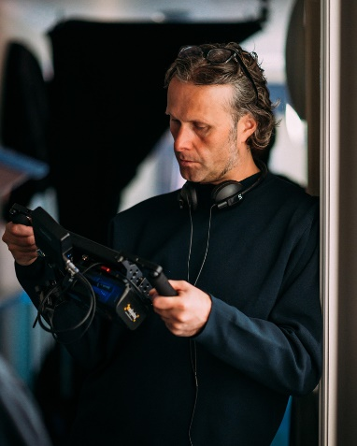

BAFTA winning TV Director | Screenwriter

martin@martinsmithonline.co.uk

[Own website](http://www.martinsmithonline.co.uk) | [Agent](https://www.unitedagents.co.uk/martin-smith)

List End

**Dorothy Jane Stewart**

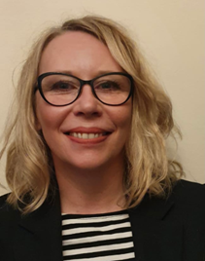

Scriptwriter

dorothyjane.stewart@sky.com

[Agent](https://www.independenttalent.com/writers/dorothy-jane-stewart/)

List End

**Zoe Swann**



Writer

hello@zswann.com

[Own website](https://www.zswann.com)

List End

**Drew Taylor-Wilson**



Writer | Director

Drew_taylor@hotmail.co.uk

[Own website](https://www.drewmakestheatre.com/)

List End

**Maria Zani**

**A woman with long black hair**

Director | producer | actor | writer | development producer | disability consultant

mariazani00@gmail.com

[LinkedIn](https://www.linkedin.com/in/mariazani) | [IMDB](https://www.imdb.com/name/nm6256329/)